|  |  |
| --- | --- |
| **Name** | Modi Omkar |
| **Roll No.** | 19EE30018 |

**Experiment #1**

Scott Connection and Vector Groups

A. Study of Scott Connected Transformers

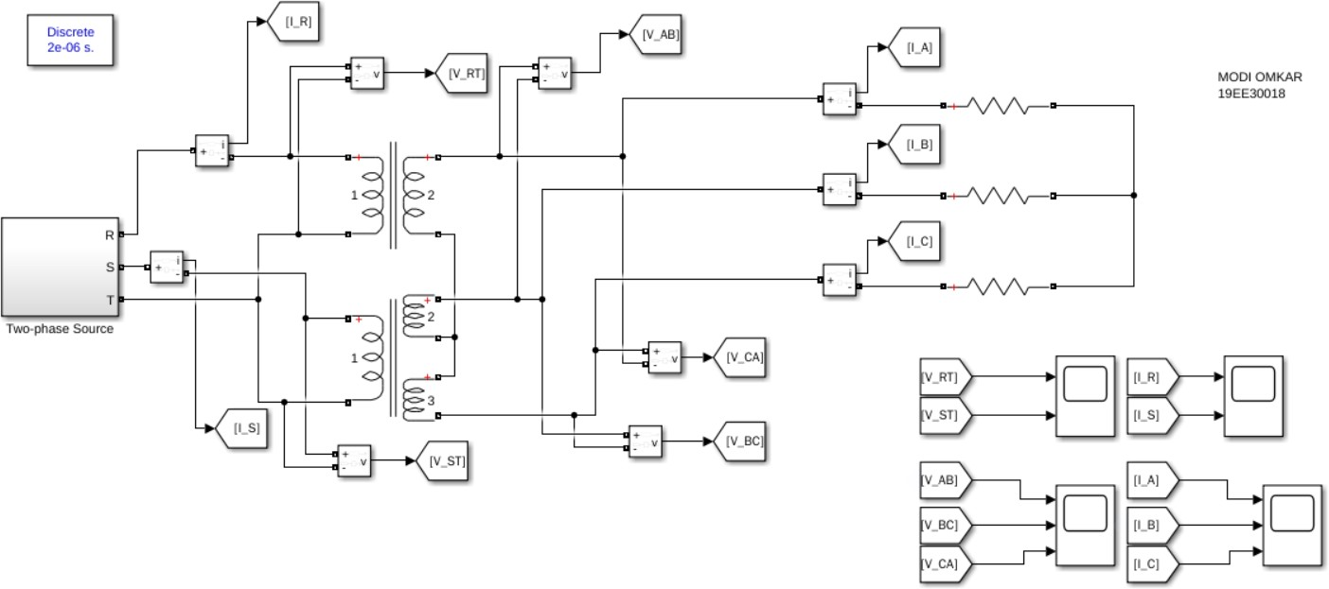

|  |  |  |  |  |  |  |  |  |  |  |
| --- | --- | --- | --- | --- | --- | --- | --- | --- | --- | --- |
| ZA(Ω) | ZB(Ω) | ZC(Ω) | IA(A) | IB(A) | IC(A) | VAB(V) | VBC(V) | VCA(V) | IR(A) | IS(A) |
| 15 | 15 | 15 | 16.79 | 16.98 | 16.38 | 430.00 | 432.50 | 427.30 | 14.86 | 14.84 |
| 10∠30 | 10∠30 | 10∠30 | 7.68 | 7.57 | 7.537 | 432.3 | 423.9 | 430.4 | 7.62 | 7.89 |
| 20∠45 | 20∠45 | 20∠45 | 2.80 | 2.78 | 2.78 | 436.3 | 432.2 | 437.7 | 3.395 | 3.819 |

|  |  |  |  |  |  |  |  |  |  |  |
| --- | --- | --- | --- | --- | --- | --- | --- | --- | --- | --- |
| 12∠  − 60 | 12∠  − 60 | 12∠6  − 0 | 40.7 | 42.64 | 39.09 | 458.3 | 441.7 | 419.9 | 35.3 | 35.49 |
| 10 | 14 | 18 | 21.24 | 18.86 | 15.55 | 440.3 | 430.1 | 429.2 | 18.64 | 14.19 |
| 20∠45 | 10∠30 | 10∠30 | 3.52 | 6.58 | 6.89 | 434.6 | 423.9 | 432.5 | 4.05 | 7.89 |

**VRT-VST**

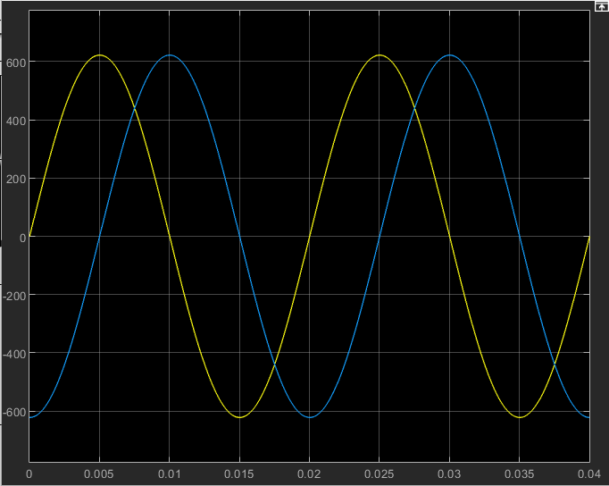

**Ir-Is**

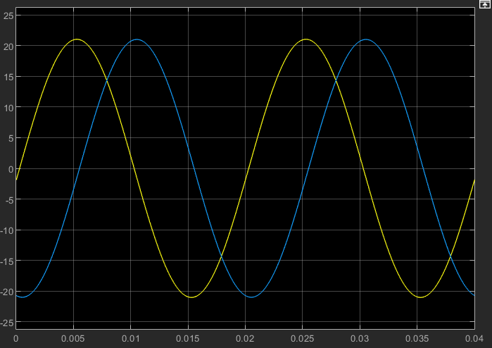

**Vab-Vbc-Vca**

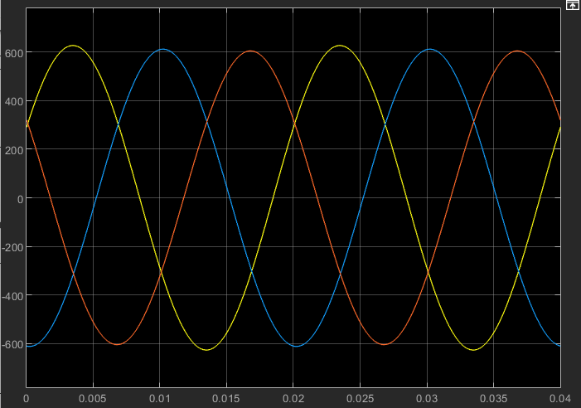

**IA-IB-Ic**

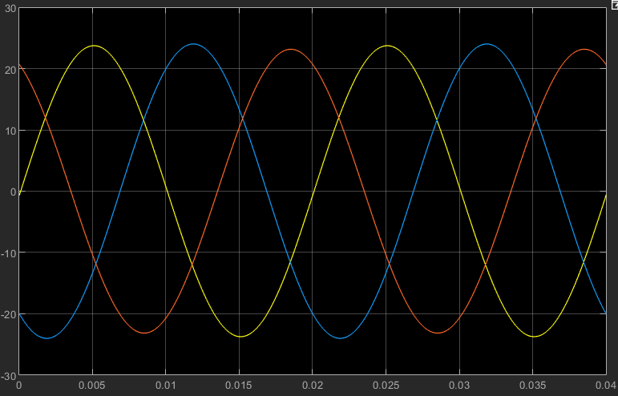

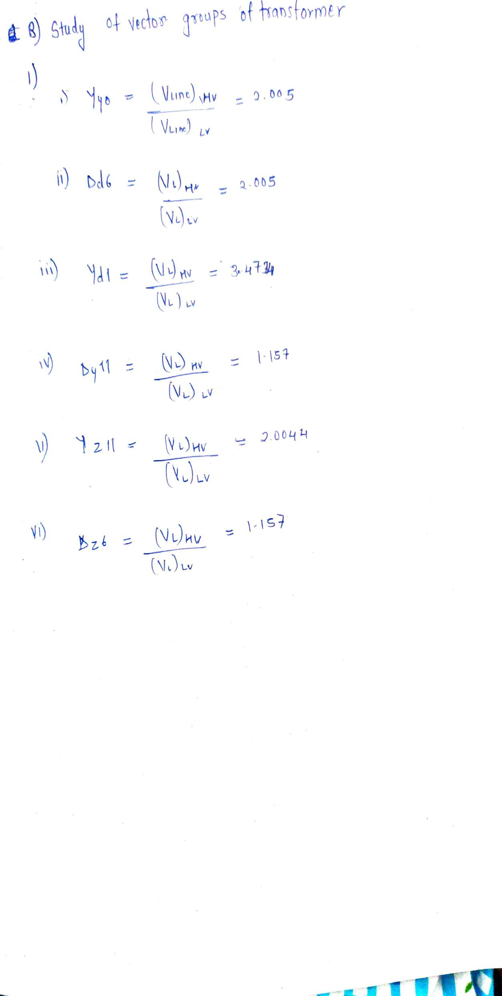

plot a line voltage of the HV side, and the corresponding line voltage on the LV sidefor any 3 configurations

1. **For Yy0:**

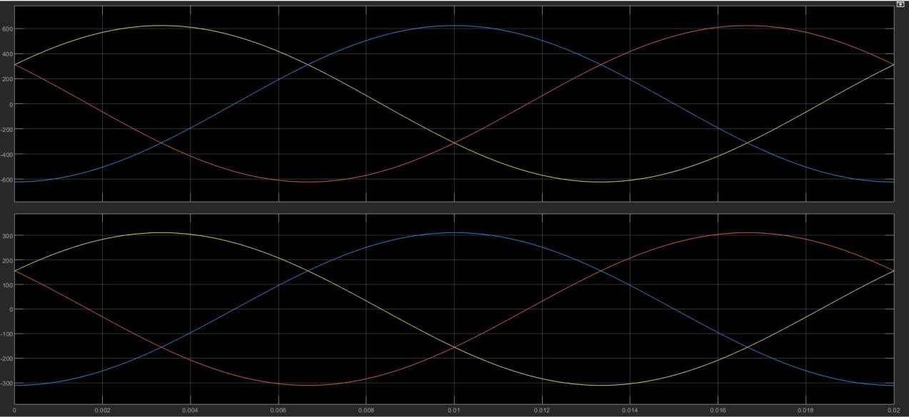

1. **For Dd6:**

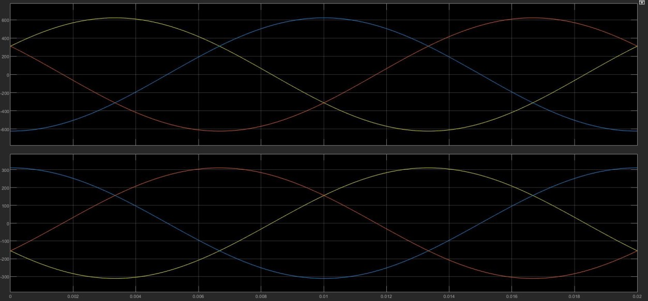

1. **For Dy11:**

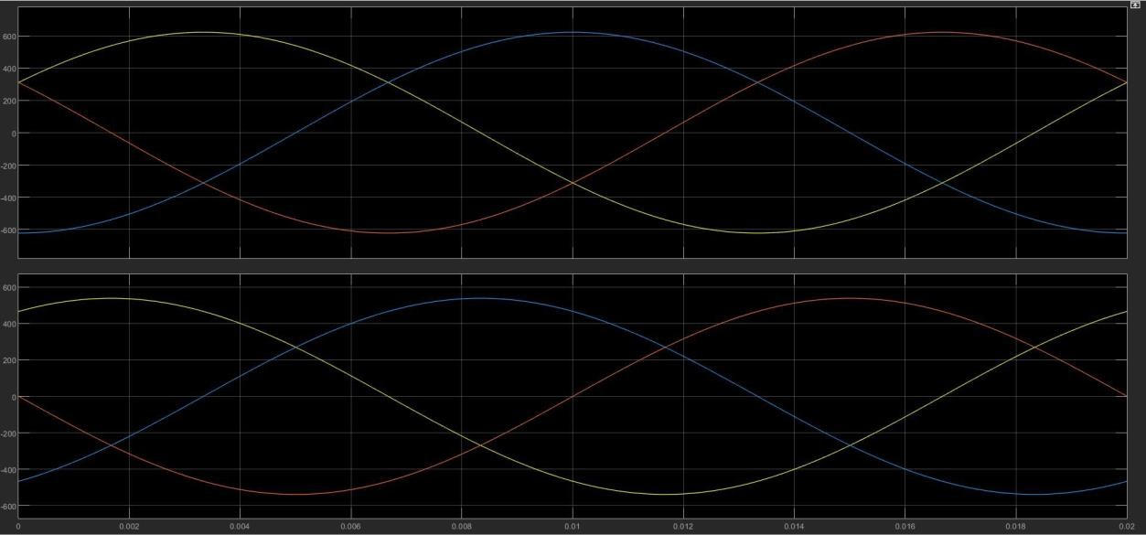

1. **For Dy11, with a one phase of load disconnected from the transformer (3 kW load):**
   1. **Line current on primary side (same as phase current due to Delta connection on primary) :**

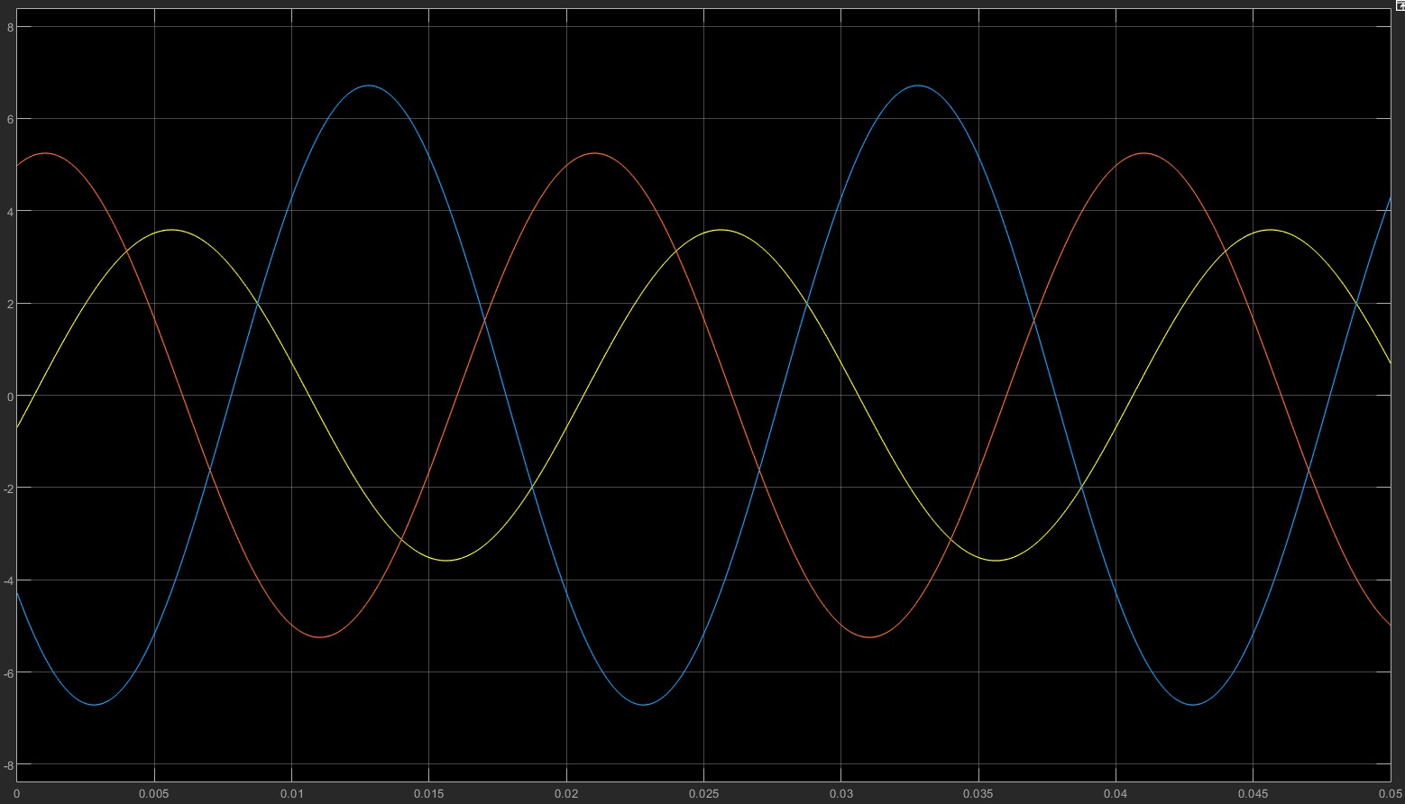

* 1. **Line current on secondary side:**

